**COC Additional Request**

1. Incident Report

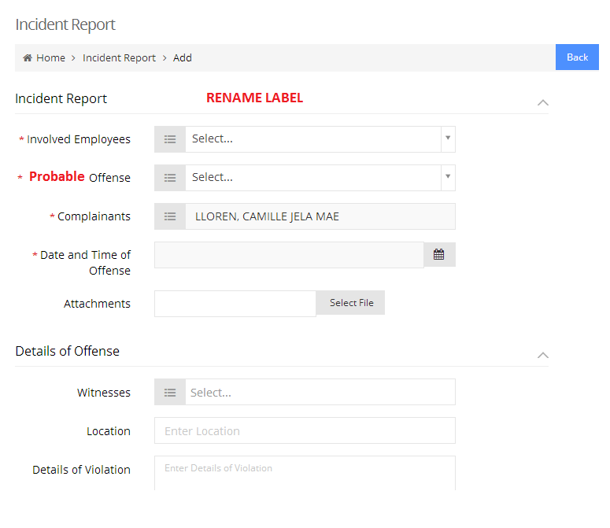

Note:

* Check notification (bell)
* Check email template
* Check printing

1. 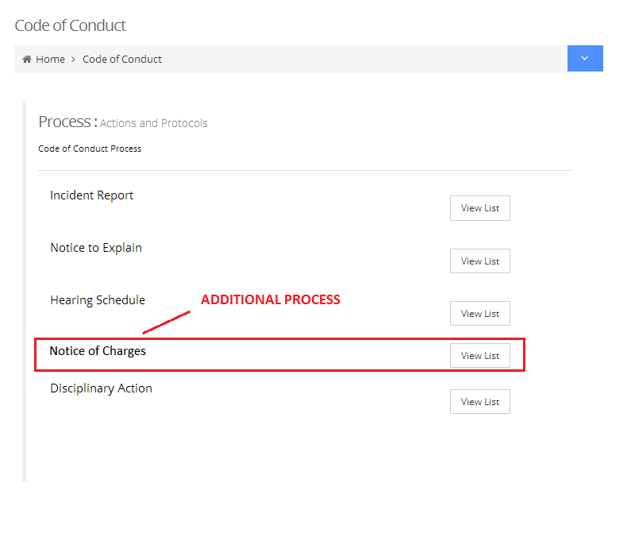Additional Process – Notice of Charges

**FROM HEARING SCHEDULE**

* Immediate superior to send the notice of charges to involve employee.

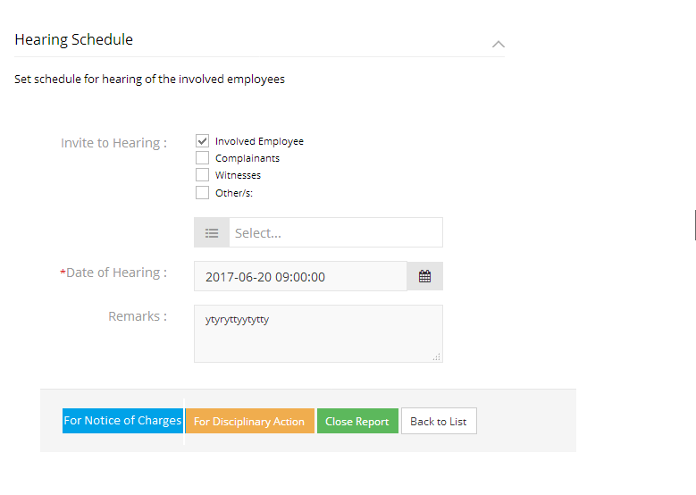

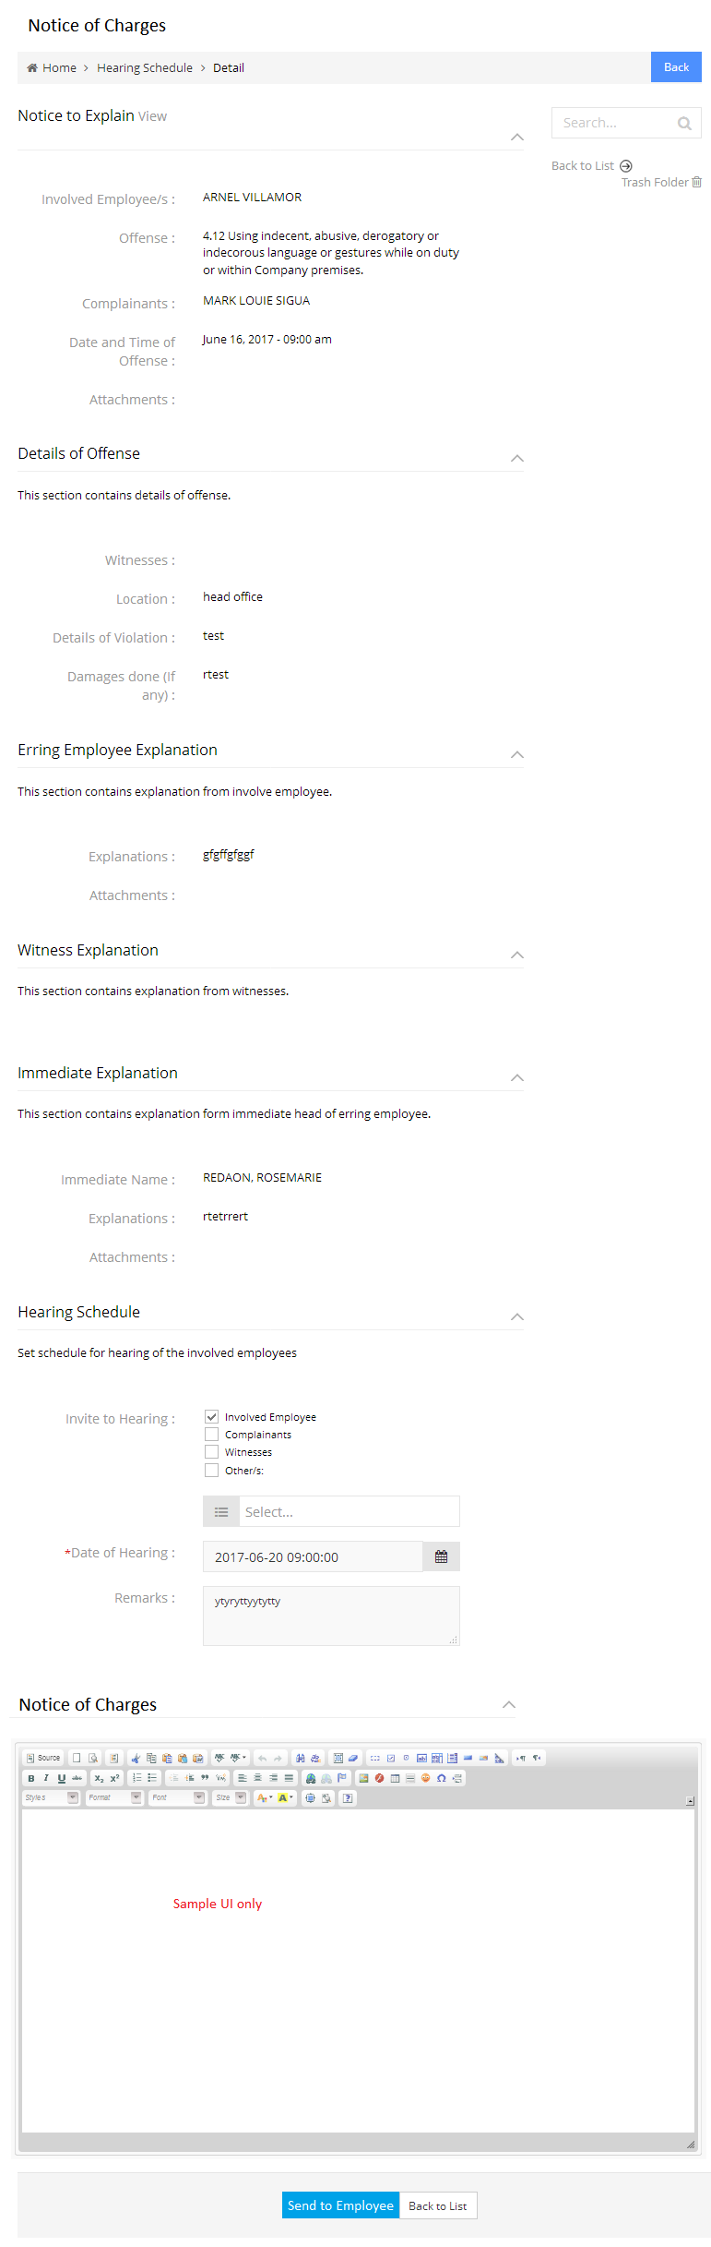

Immediate superior to create the reports/findings then send to involve employee for comments.

* Involve employee to response/comment on the notice of charges then send to immediate superior.

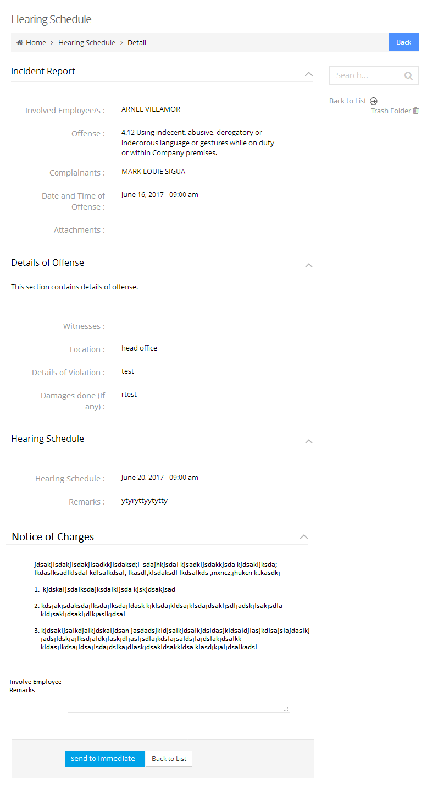

* Immediate superior to set the IR for DA or for Hearing schedule again.

